Aaron’s
Activity Portfolio
&
Concepts

A guide to engaging children in the art of learning and other miscellaneous ideas
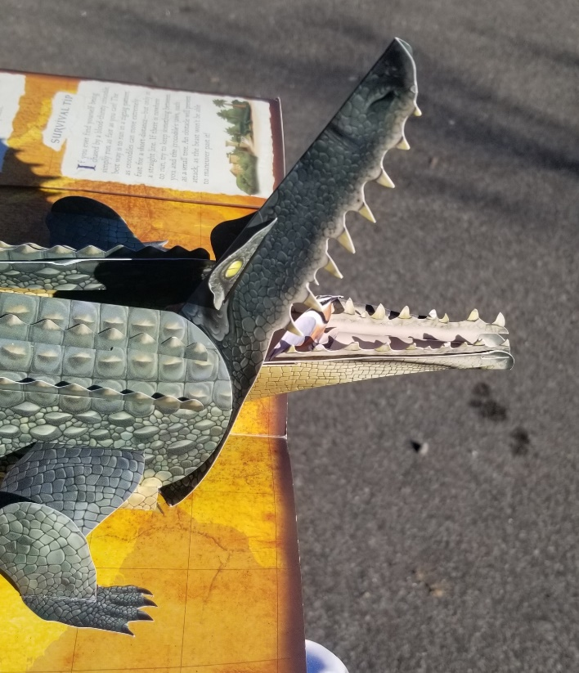

The Golden Rule:
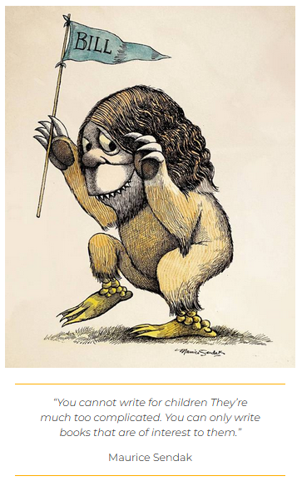
Reading is not interesting to anybody but the linguists and anthropologists that study it.

The information that words on a page contain, however, can be priceless. If you are not interested in what you are having your child read, the likelihood that this kid will find it interesting themselves goes down considerably. Treat that kid’s brain like your own!
Kids are clever and curious. If you need a reminder of this fact, reread Huckleberry Finn. Wonder, intrigue, and even fear are cornerstones of learning. Enter the unknown!
Light Board Tracing
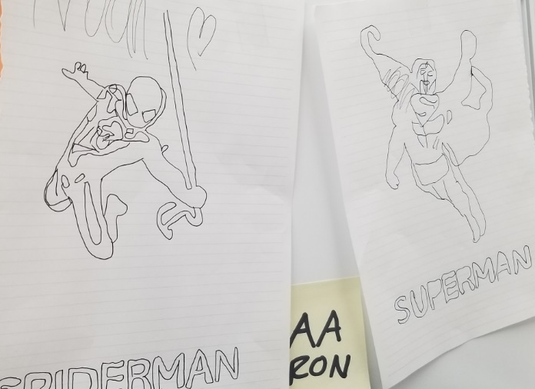

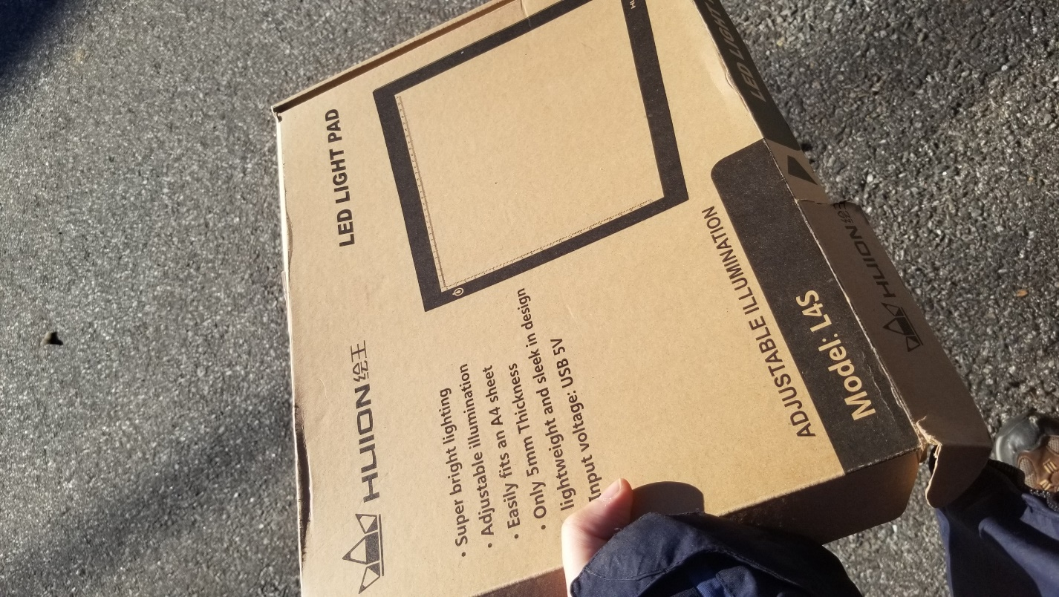
A light board is a simple device that projects light outward so that artists can trace images between multiple sheets of paper. Animators use them to create an “onion skin” to produce fluid motion between frames in an animated film.

When they see it, kids assume I have brought an iPad or tablet. I leave them in suspense. Let the kids feel the board and hold it. Let them figure out where the plugs go and let them set it up themselves. Let them find the power-button and wonder if it is broken when all they receive is white light.


Bring prints of superheroes or other characters relevant to the child’s interests. Use tape to fix the characters in place on the board so the papers don’t slide around while tracing.

Force the child to trace the name of the character afterwards.
Pop Up Books

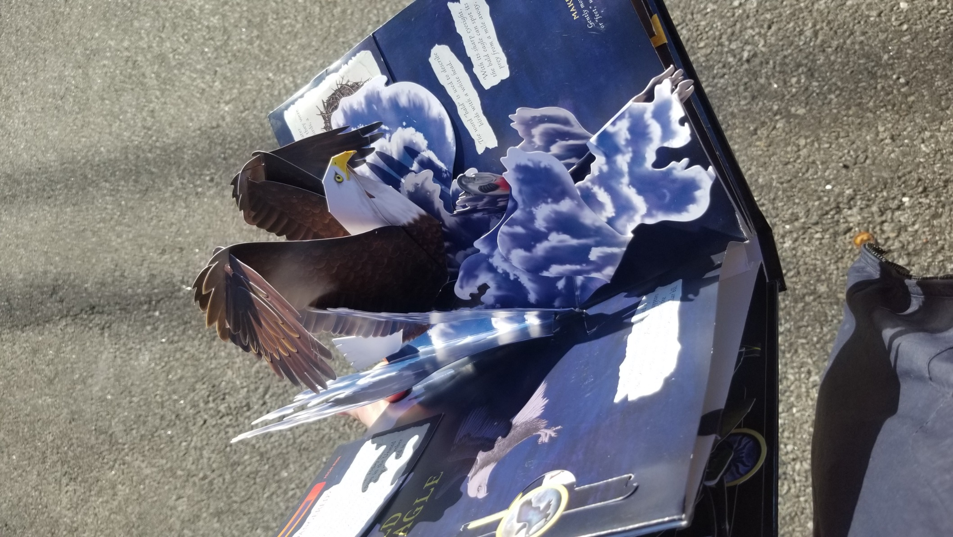

The more pull tabs, the better!

Custom Decodable Books
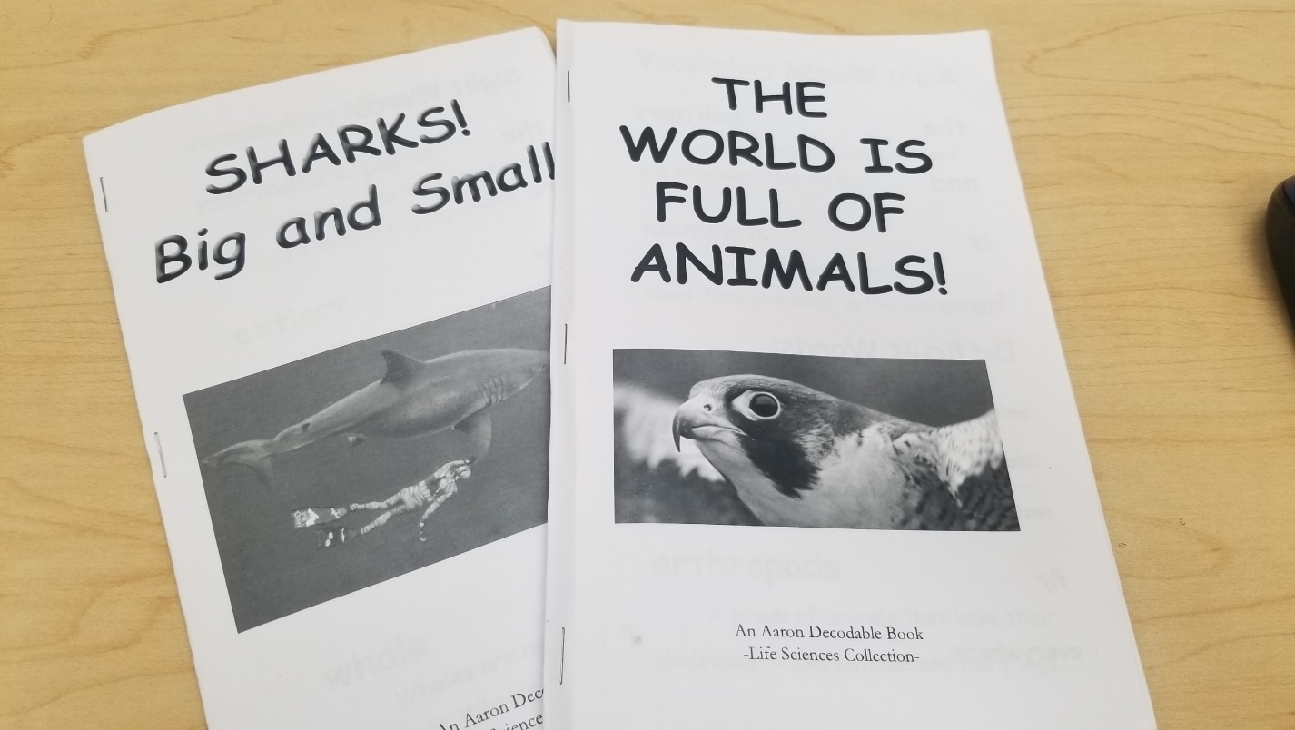
I used my knowledge of Adobe InDesign to create custom decodable books tailored to the interest of one of my students. He loves animals, so I set out to create a series of Life Science books that would grow in complexity as the child progressed.

The decodables sold by literacy companies are painfully boring and contain the laziest, most uninspired clip art imaginable. They save time, but they are rarely engaging. I decided to adapt the format to my own needs. Some of the words contained are by necessity too complex for a rising reader, so ensure the child that you will step in and help when these words are reached. The latter pages tend to be harder, so reward your reader by taking over halfway through.

InDesign was necessary for print formatting—there is a specific order that pages must be printed in in order for them to form a proper booklet. Automating this process saves a lot of time, but it took me many iterations to get it right. I paid for the adobe software myself. If other tutors express interest, I recommend that Hopewell obtains its own Adobe license to share in the office.
Researching & Planning Decodable Lessons
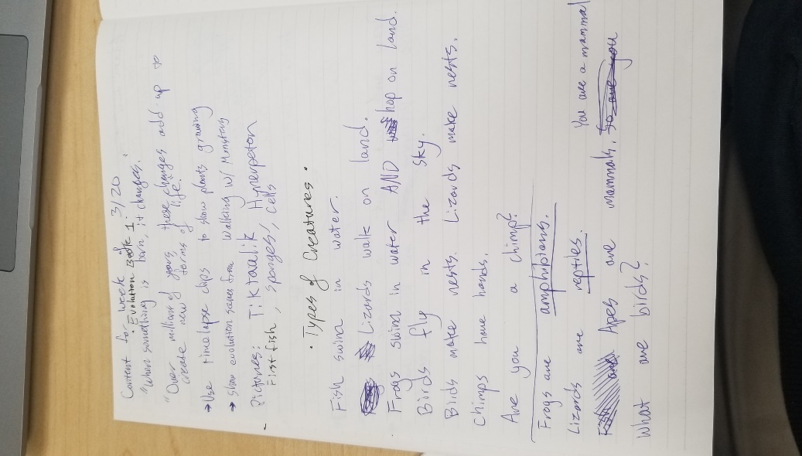
I kept a notebook to keep track of case notes and observations about my child’s interests. I brainstormed by keeping a list of potential topics. I knew I wanted to teach evolution and prehistoric animals, but first I wanted to make sure the child learned about the basic differences between animals (insects, mammals, reptiles). As it turns out, my student was already aware of these distinctions and enjoyed teaching them back to me.

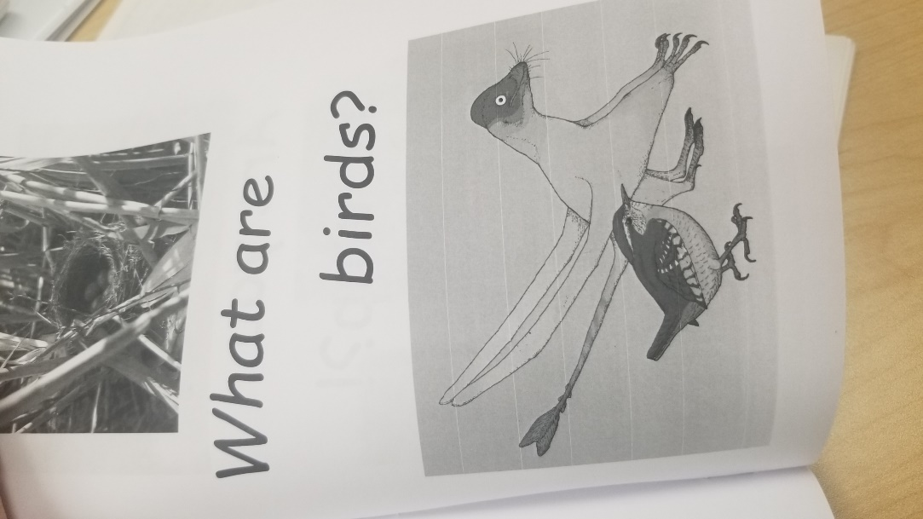
I would go on Wikipedia or refer to a textbook to do some light research. To prepare for the final book, I wrote out a basic outline of what each page ought to say and what kind of picture it needed. I sourced all my images from Google for the final booklet template.

This project is a win-win. The student gets a customized lesson specific to their interests, and the teacher has the opportunity to make something meaningful and learn a ton along the way.
Google It!!

Children will naturally, over the course of lessons, ask questions that you do not know how to answer or explain. Use these moments as an opportunity to teach spelling, typing, letter recognition, and new information all at the same time.
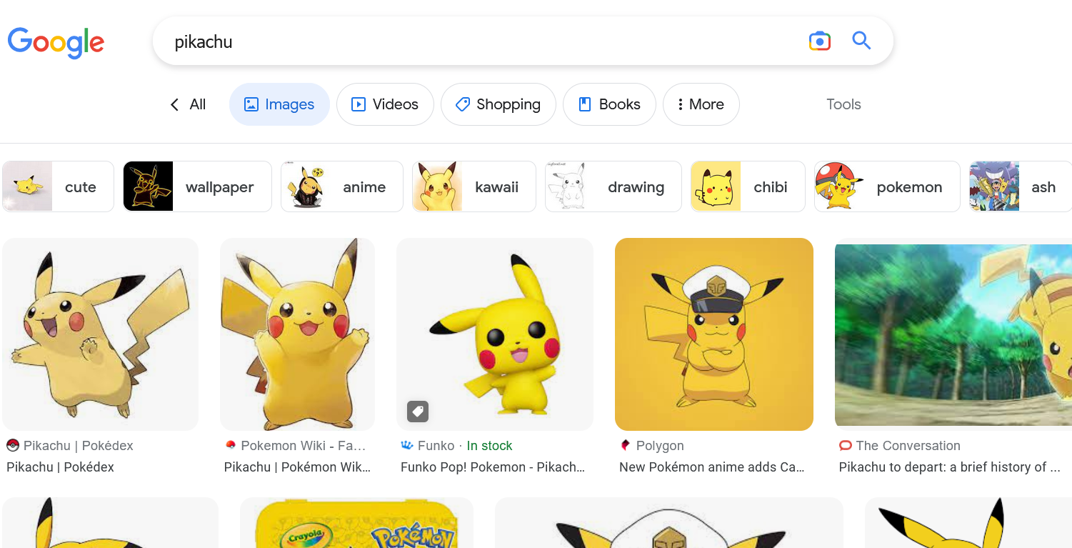

Google Images to the rescue!

This activity also familiarizes young people with a tool that they will use for the rest of their lives. You can spell the words for the student. You can also help the student break up the words into phonemes so they can figure it out partially or entirely by themselves.

Video Editing
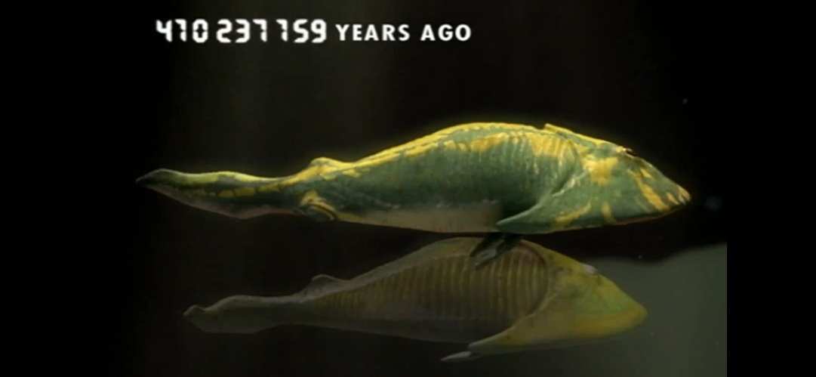

My earliest earliest memories involve watching BBC animal documentaries with my brother. He pretty much always got to choose what was on the TV. Some of the scenes were scary. Some of them were wonderful and inspiring. As a five year old, the words “herbivore,” “carnivore,” and “theropod” were prominent elements of my childhood vocabulary. Kids immersed in complex information will tend to absorb complex information.

I took some time to edit clips together from an old dinosaur documentary to show to a student. I never ended up showing this particular video, but I would much prefer to show something real rather than something “made for kids.” Kids can detect when they are being condescended to. Certain kinds of “kid friendly” content stray into the very same mass-fabricated territory that cheap decodable books fall into.

Editing your own clips, whether they be documentary clips or dance clips or scenes from TV, allows the teacher to select extremely specific content from their own experiences to inform the subject of the class. Kids also just love video, same as adults.

Using AI to create ART

AI is a powerful tool that uses the written word to drive the creation of fantastic works of art. Basically, a computer has been trained to look at hundreds of thousands to pieces of human-made art in order to create its own artworks based on keywords offered by a human.
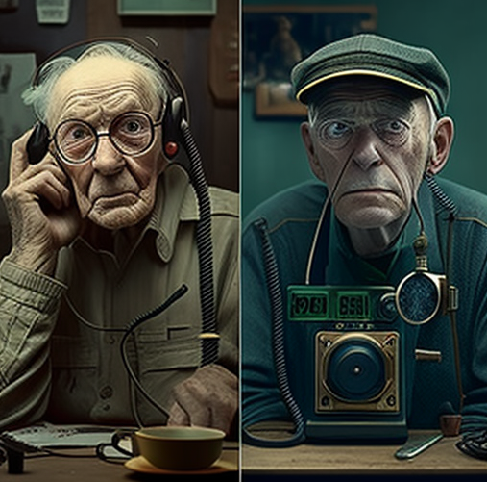
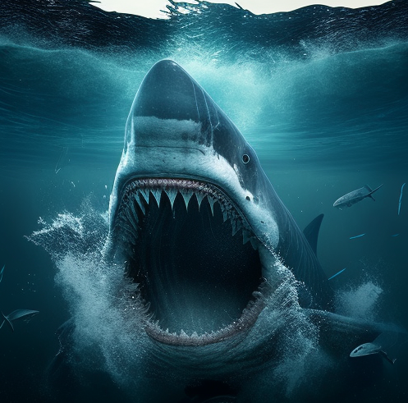
Using the Discord based AI engine Midjourney, I had my student spell out keywords to generate their very own totally unique pieces of artwork. In the example above, the student typed the question: “When did we get made?”
Sometimes the results are strange or don’t make much sense. Other times, like when the student typed “Megalodon,” the results are very concrete.
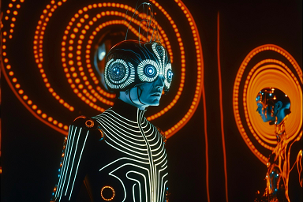

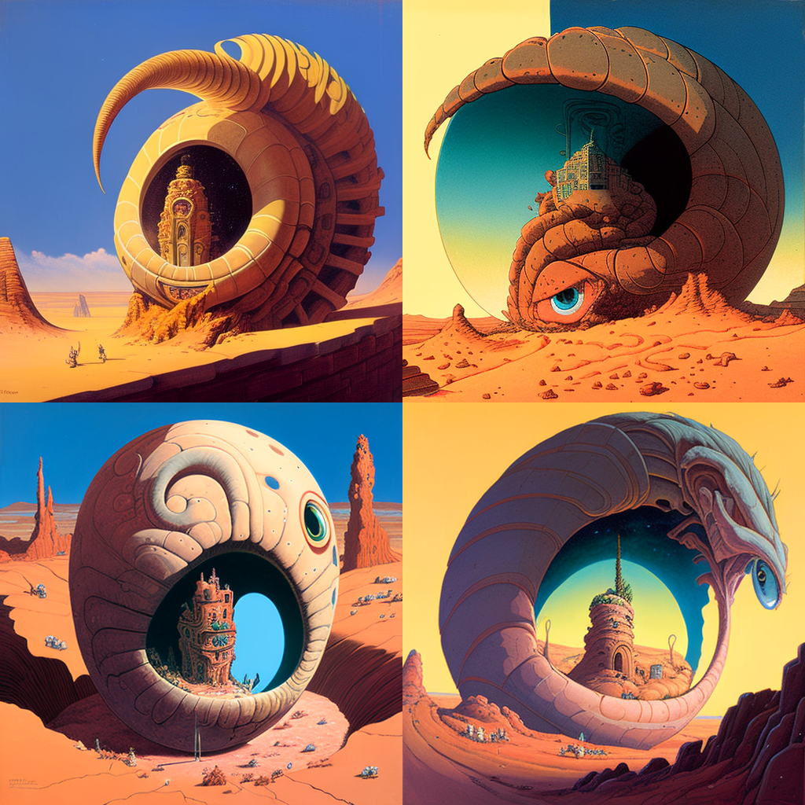

My favorite piece of AI generated art, a desert landscape featuring a fantastical castle.

Unimplemented Schematics

Phonetic Typing Machine:

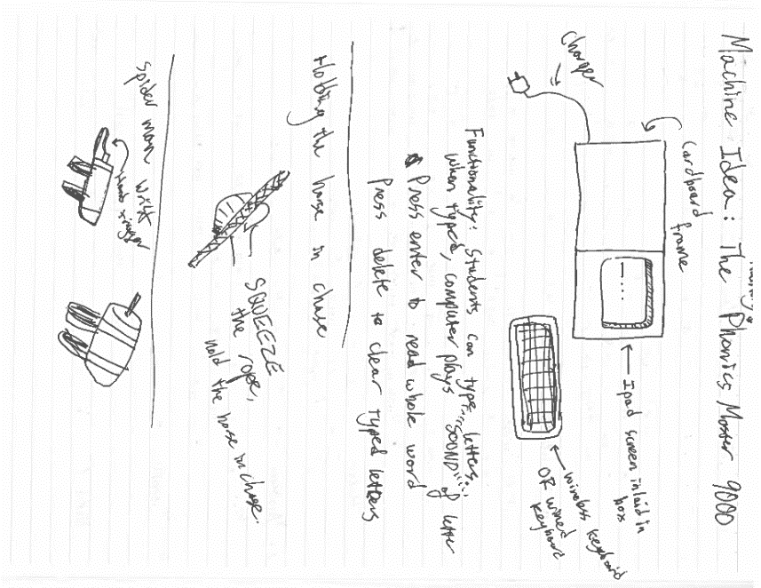
I created plans for a number of projects that never came to fruition. The first was a “typing machine,” a magical box with a screen and a keyboard that would phonetically repeat the sounds of any letter typed into it. This also keeps grubby hands away from my personal laptop.

There are apps on tablets that accomplish a similar idea. I imagine having a phonetic reference of letters would help children when decoding or spelling themselves. The simple tactile act of seeking a letter, pushing a button, and then receiving auditory feedback is (I imagine) a strong multisensory learning tool.

SPIDER MAN GAME:
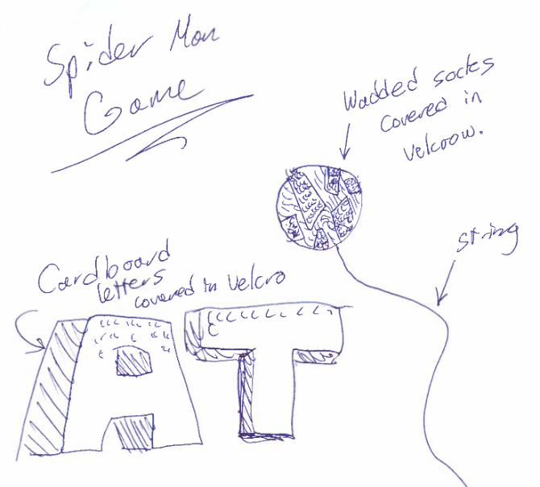
I never had time to make this game, though I think it would have been super fun to play. Basically, you set up big cardboard letters covered in Velcro. You have a ball of wadded socks or cloth or some other soft, non-painful material on the end of a string that is ALSO COVERED IN VELCRO.
See what I am getting at? The kid can swing the ball to pull down letters just like Spiderman! This could be useful in Kilpatrick drills, which already require the child to delete or substitute letters in words.

SPY GAME / SECRET AGENT GAME w/ Walkie Talkies or Cans:

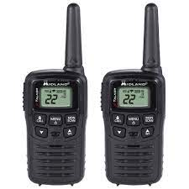
I never had time to make this game either. Essentially, a child is given a scavenger hunt with secret codes (letters, nonsense words, and real sentences) hidden around the house or yard. The child, with a walkie talkie or can+string must find these hidden things and transmit the codes to you (HQ). Then you will give the child their next hint or mission. This just sounds like a load of fun and gives practical purpose to otherwise overdone decoding exercises.

Floor is Lava Game

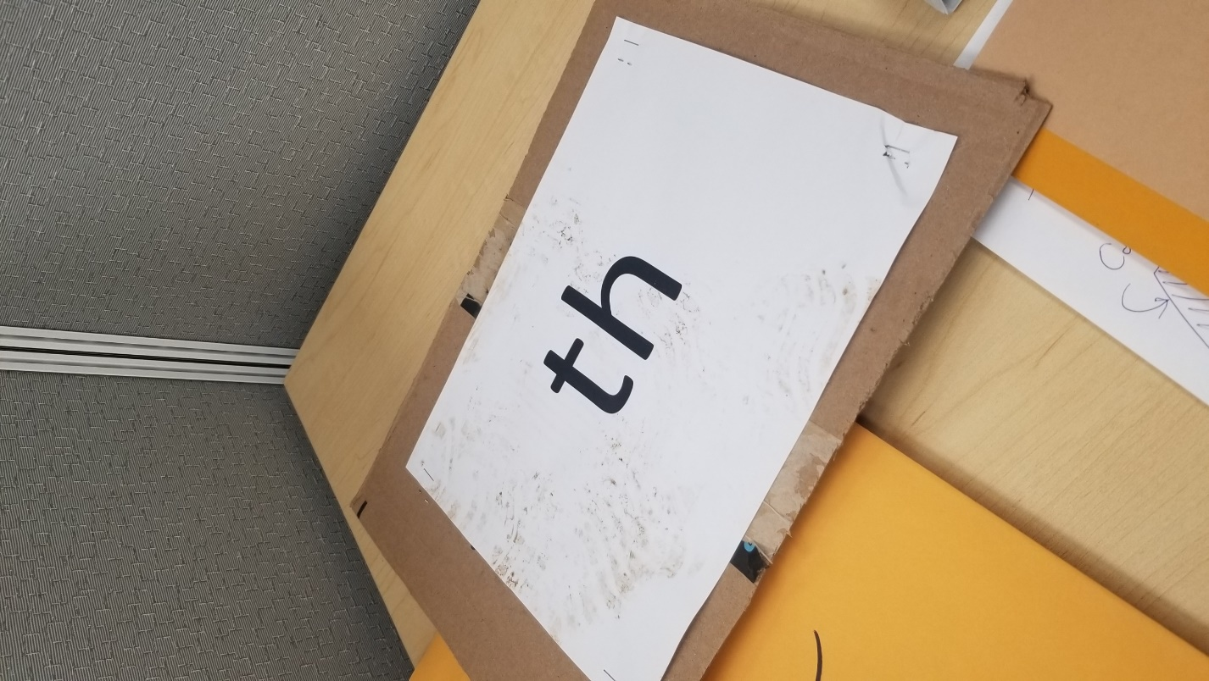
This movement activity has the potential to tire out an overactive student. To the sound of some hype music (I like “Eye of the Tiger”), the student must leap between cardboard rocks placed on the floor.

The rocks have letters, sounds, or whole words placed on them. The student must move between the rocks to avoid the lava that is slowly following them (you). Ideally, the student needs to yell out the sound or word before jumping.

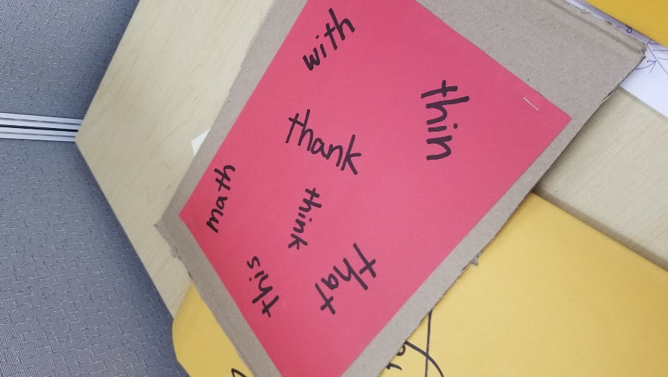
Sometimes, a molten rock will fall from the ceiling! When this happens, pretend to drop a cardboard rock on their head! To protect themselves, students need to lift up one of the rocks on the floor to shield themselves. It just so happens that there are words on the bottom of the rocks. The student must successfully read a word in order to survive the falling rock! Afterwards, the game continues. Over time, remove rocks to make the game more hectic.
Kilpatrick & Fundations Digitized

I have digitized all of the Kilpatrick Drills found inside the “Equipped for Reading Success” textbook. I have made them somewhat ctr-f-able, so you should be able to search them for the specific parts you need.
I have also digitized the appendices, because they contain useful definitions.

I have also begun the process of digitizing the Fundations curriculum. My digital artifact contains a table of contents with both textbook page numbers and internal page numbers so that tutors can navigate to exactly the lessons they require to build an SLR.
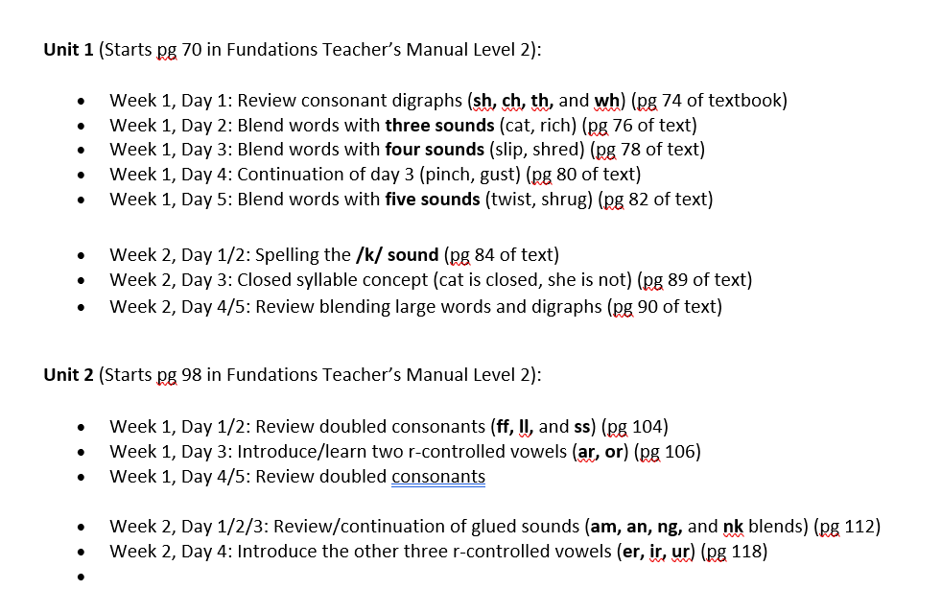
Unfortunately, I did not have time to finish this project. I hope to give Clare a strong enough template to give future tutors a chance to continue this important project.
Literacy in Minecraft

I wrote my undergrad thesis on the practical applications of survival literature in classrooms through the 17th century to today with an overarching focus on how the video game Minecraft has been informed by these literary trends and implemented in classrooms itself.
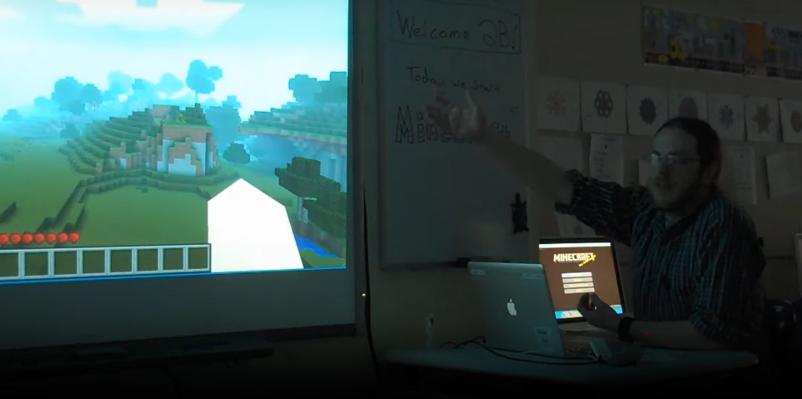
One of my dreams is to be a “Minecraft Teacher,” like Joel, the creator of Minecraft EDU. All the way back in 2011, Joel taught an afterschool class that introduced first graders to computers through interactive experiences within Minecraft. I have long taken inspiration from the videos that he posted of his lessons on Youtube (click here).
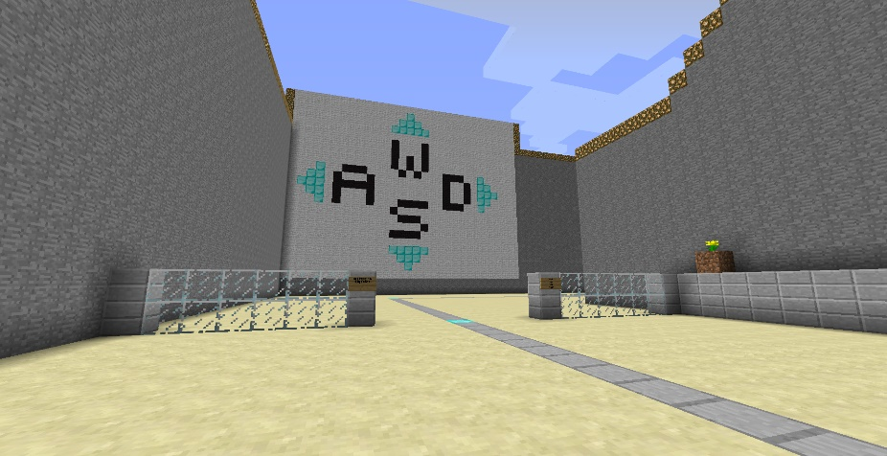
When I realized I needed to leave Hopewell, I decided to put some of what I have learned into action. Using Joel’s Minecraft EDU map as my model, I created a custom world for my student that used in-game signs to teach the game and inform activities.

I purposefully do not teach the student the controls immediately. I leave students to fumble around like a newborn in this new environment. Instinctively, all of them have attempted to use the arrow keys to move around. No dice! They need to look at the signs in-game and read them in order to learn that the W key allows them to move forward, and the S key allows them to move backwards.
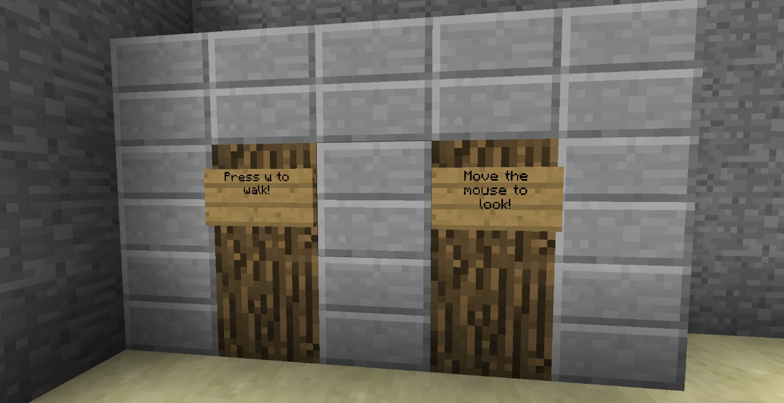
They will eventually hit a steep section of the map that requires them to jump. Clever players will realize that a giant SPACE BAR sign means that the student must click the space bar to make progress!

The best portion of the map is a maze at the very end. Students cannot escape the maze without reading signs telling them to either go left or right, or to NOT go left or right! Getting lost can lead to some silly dead end rooms.
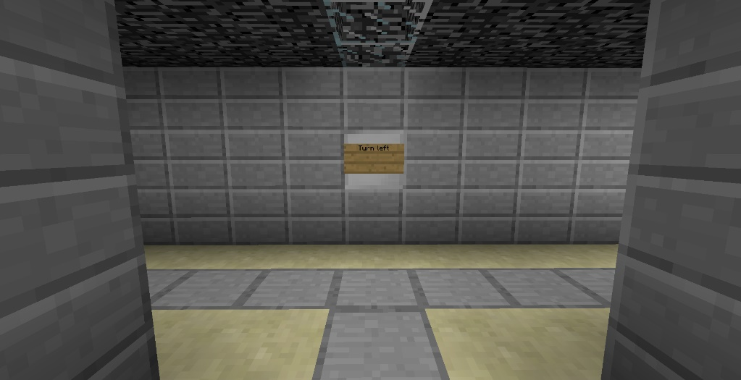

The map was such a success that my student demanded more. For the next class, I created an adventure world set on desert islands in a deep ocean. I set the game up like a treasure hunt. The student is free to explore the map at their leisure with no barriers to hem them into a linear track. However, to make progress toward finding buried treasure and hidden temples, the player must read instructions and interpret a map scavenger-hunt style. Landmarks, like a giant Spongebob, are used to keep the player oriented.
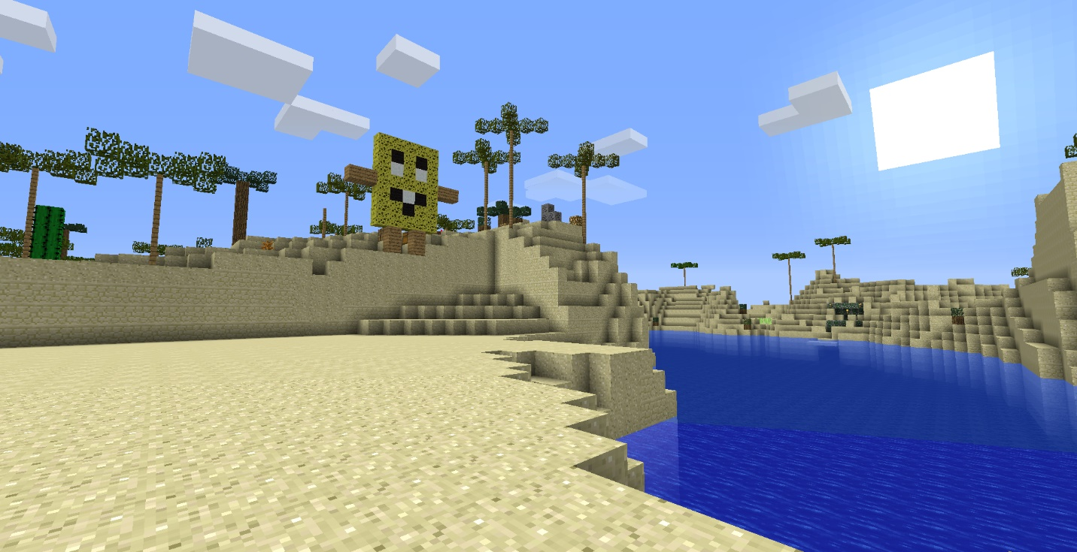
Wow! The freedom to explore gripped my student. He was constantly moving between the game to the pamphlets I provided to guide his own adventure.

Of course, prepare for the lesson by introducing basic concepts like left and right click on a mouse. Always use an external mouse and keyboard. Do not let the child play with the track pad or touch screen.

SAFETY MEASURES:

Of course, I took measures to make sure that the student experience within the game was safe and guided. I modified the game with the very same codes that Joel used in his Minecraft EDU lessons in order to create the maps and make them kid-proof.

For example, there are no monsters in the game. Only peaceful animals can appear in the game world. The child’s in-game avatar is invincible and cannot be hurt in any way. If the lighting is too dim for a particular student, or if the game’s simulated darkness in the maze is at all scary, there are options to light up the entire screen. There are options to fly and teleport as well, so the player can never get stuck.

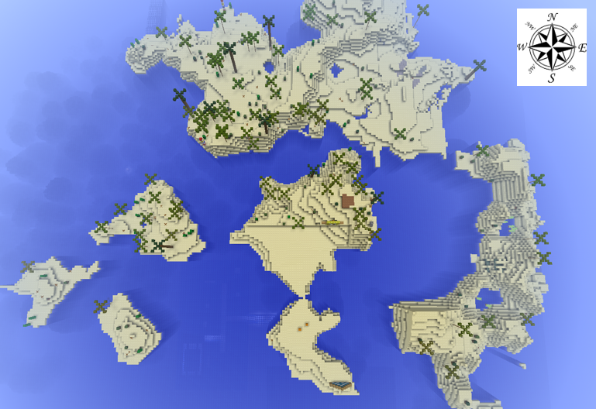
The modified game also comes with a set of commands that students can use to practice typing and achieve interesting effects. Spelling the names of animals, for example, spawns them into the world. The student can change the time of day or fly too. Players can power up their own character so that all blocks are destroyed instantaneously with one punch. The possibilities are endless!

Final Advice: BEWARE THE TEACHER VOICE!!!

Without realizing it, many adults adopt a sort of baby voice when talking to young students. This is fine for kindergarteners, but some first graders start to notice it, and older students definitely do.

Kids want to be respected, just like you and me. Speak to a student in the same frank manner that you might speak to a peer, and you may be rewarded with a student that listens and speaks to you with greater maturity.

In that same vein, give some resistance. Don’t fold to the child. The student looks to you to direct their attention in meaningful, refreshing ways. Ask tough questions, be mysterious! Let the children stumble on the rocks a bit before giving away critical information. Mistakes are an important part of the learning process, and a sense of discovery drives it all.

Don’t make empty promises, but carry yourself like you always have something up your sleeve (and hopefully you do!). You have a lot more experience in your head than this small human before you, so leverage that. Tell relevant stories, talk of times that you have failed or messed up or succeeded when you were a kid. And of course, don’t be afraid to say, “I don’t know!” Do not give children the mistaken impression, the lie, that adults have everything figured out. We clearly don’t, but by asking questions and thinking critically, children and adults alike can start to tackle the problems that perplex us.

